**Lab 1: Understanding ORM with a Retail Inventory System**

**1** **What is ORM**

**Ans :ORM** stands for **Object-Relational Mapping**. It is a technique that allows developers to interact with a **relational database** (like SQL Server, MySQL, etc.) using **object-oriented programming (OOP)** concepts. Instead of writing raw SQL queries, developers can use objects, classes, and methods to perform database operations like insert, update, delete, and read.

In C#, ORM tools like **Entity Framework Core** automatically map classes to database tables using a process called **convention-based mapping** or **attribute-based configuration**.

**2.EF Core vs EF Framework:**

**Ans: Entity Framework Core (EF Core)** is a modern, lightweight, and cross-platform ORM built from scratch to support .NET Core and beyond. It offers advanced features like full async support, LINQ, and compiled queries for better performance and flexibility. In contrast, **Entity Framework 6 (EF6)** is a mature ORM limited to the Windows-only .NET Framework. While EF6 has a larger set of legacy features and broader stability for older applications, it lacks the performance optimizations and cross-platform support found in EF Core. Therefore, EF Core is ideal for new, scalable, and cloud-based applications, whereas EF6 is better suited for maintaining existing Windows-based systems.

1. **EF Core 8.0 Features:**

### **1. JSON Column Mapping**

Allows storing and querying structured data (like dictionaries or nested objects) directly in a JSON column in SQL Server.

### **2. Compiled Models**

Improves startup and runtime performance by compiling your entity models ahead of time.

### **3. Interceptors**

You can hook into EF Core’s behavior (like logging SQL queries, auditing, or preventing certain writes).

### **4. Better Bulk Operations**

More efficient insert/update/delete operations in bulk.

1. **Create a .NET Console App:**

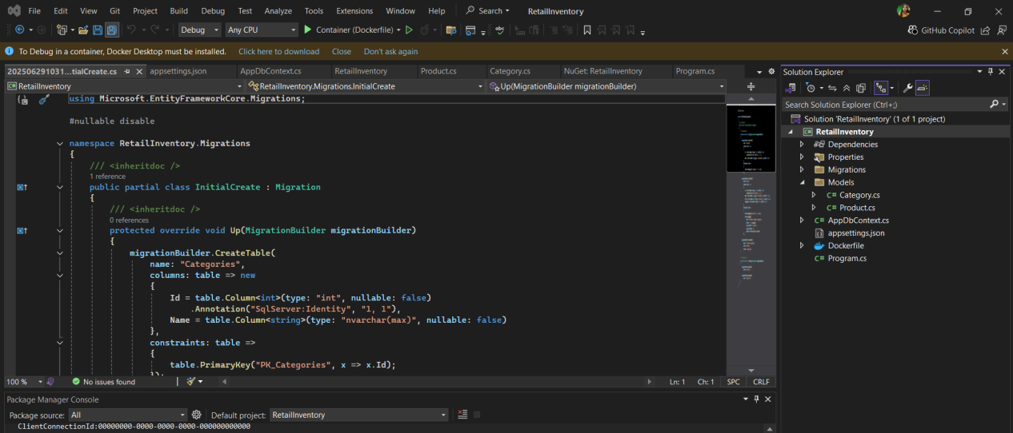

**5. Install EF Core Packages:**

